# Use Cases

USECASE2.png

**IMPROVEMENT NEEDED!!!  
  
‘I believe you need at least one more type of user, namely the staff. You may want to have different levels of staff (e.g. line manager, supervisor and technician).  
I am not sure that it should be the Admin to assign staff rather than assigning a flight to a terminal queue with all the jobs assigned to that terminal. In this case the staff assigned to that terminal just has to check the next job in the queue. Everything else looks good. ‘**

**- Pedro**

**IMPROVED VERSION OF USECASE DIAGRAM**

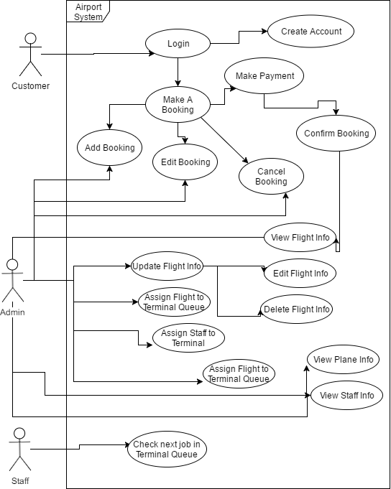

|  |  |  |
| --- | --- | --- |
| **ID:** 1 | **Name:** Create Account | |
| **Actors Involved:** Customer | | **Preconditions:** User runs system/ selects create from the Main Menu |
| **Main Flow**  The user enters the create account through the selection on the main menu, the user is prompted with each detail, e.g. forename, surname, phone number. Each detail is validated such as length check on phone number and format check on email address. When all valid data is entered the system asks the user for confirmation, if the user selects yes, the system will save that users valid details to the xml file. | | **Alternative Flow**   1. User enters invalid data, error message occurs, user cannot continue until valid data is entered 2. User doesn’t confirm details, system returns to the main menu without saving 3. Details entered are already in the xml file, error message occurs, create account function begins again from the start |
| **Post conditions:** Customer details are saved to the XML file | | |

|  |  |  |
| --- | --- | --- |
| **ID:** 2 | **Name:** Login | |
| **Actors Involved:** Customer | | **Preconditions:** user has created an account |
| **Main Flow**  The user enters the log-in through the selection on the main menu the user enters their email and password, the system checks the xml file for a matching email and password and returns the user to the main menu, logged in | | **Alternative Flow**   1. User enters invalid data; an error message occurs until the user enters valid log in details. The user cannot access features such as ‘Make a Booking’ until they have logged in successfully. |
| **Post conditions:** User returns to the main menu, logged in as an admin or regular user. | | |

|  |  |  |
| --- | --- | --- |
| **ID:** 3 | **Name:** Make A Booking | |
| **Actors Involved:** Customer | | **Preconditions:** User is logged in |
| **Main Flow**  The user enters the ‘Make a Booking’ through the main menu, in which they will be asked to select their flight locations, flight and seat after the system displays all available seats on that flight, prompting the user to enter another seat. When the user has finished booking their seat they will confirm their booking which will be added to the xml file once the user has made their payment. | | **Alternative Flow**   1. The user selects an unavailable or invalid seat name e.g ‘A566336’ an error message will occur and the booking will not be saved until a valid seat is entered. |
| **Post conditions:** Make a payment | | |

|  |  |  |
| --- | --- | --- |
| **ID:** 4 | **Name:** Add Booking | |
| **Actors Involved:** Customer, Admin | | **Preconditions:** user has already booked one seat |
| **Main Flow**  After the user, has booked one seat, they will be asked by the system if they wish to book another seat and add this extra seat to their booking, when the user selects ‘yes’ the system will run the ‘Make a Booking loop again until the user no longer wishes to book another seat and continue to the make a payment section. | | **Alternative Flow**  g |
| **Post conditions:** User makes a payment | | |

|  |  |  |
| --- | --- | --- |
| **ID:** 5 | **Name:** Make Payment | |
| **Actors Involved:** Customer | | **Preconditions:** logged in user has selected their flight and seat. |
| **Main Flow**  After the user, has selected their flight and seat the user will input their payment details which will be validated using format and length checks, a confirmation message will display when the user has successfully entered valid data and will be returned to the main menu. | | **Alternative Flow**   1. User entered invalid payment information, error message occurs, user prompted to reenter the details until they are correct. |
| **Post conditions:** Payment Confirmation | | |

|  |  |  |
| --- | --- | --- |
| **ID:** 6 | **Name:** Confirm Booking | |
| **Actors Involved:** Customer | | **Preconditions:** payment has been made |
| **Main Flow**  After the payment, has been made, the user will be asked to confirm this booking, if the user confirms the booking, the screen will display their name, flight details and payment information, the data is then saved in an xml file. | | **Alternative Flow**   1. User doesn’t confirm the booking, error message occurs, returns to the main menu. 2. Data is not saved to the xml file |
| **Post conditions:** Save XML file, return to main menu | | |

|  |  |  |
| --- | --- | --- |
| **ID:** 7 | **Name:** Edit Booking | |
| **Actors Involved:** Customer, Admin | | **Preconditions:** Booking has been confirmed |
| **Main Flow**  After a user, has made a booking, that is saved in the xml file, the user selects ‘Edit Booking’ in which their data is appended as their current booking is removed and replaced with a new booking as the user selects the flight locations, times and seat allocation, the new booking is then appended in the booking xml file. | | **Alternative Flow** |
| **Post conditions:** Add edited flight to time board / Append XML file | | |

|  |  |  |
| --- | --- | --- |
| **ID:** 8 | **Name:** Cancel Booking | |
| **Actors Involved:** Admin, Customer | | **Preconditions:** U |
| **Main Flow**  After a user, has made a booking, that is saved in the xml file, the user selects ‘Edit Booking’ in which their booking is deleted and appends the booking xml file for that booking from the user, the seat allocation removed from the system will then we available again the Make a Booking section. | | **Alternative Flow**  g |
| **Post conditions:** Add cancelled flight to time board / Append XML file | | |

|  |  |  |
| --- | --- | --- |
| **ID:** 9 | **Name:** View Flight Info | |
| **Actors Involved:** Admin, Customer, Staff | | **Preconditions:** the user is logged into the system |
| **Main Flow**  When the View Flight Info is selected from the menu regardless of access level, the flight info is displayed for each terminal, the time-board displays all times, previously sorted by time using Quicksort and placed in the queue. | | **Alternative Flow**  g |
| **Post conditions:** Return to main menu | | |

|  |  |  |
| --- | --- | --- |
| **ID:** 10 | **Name:** Update Flight Info | |
| **Actors Involved:** Admin | | **Preconditions:** User is logged in as Admin |
| **Main Flow**  If a new flight becomes available the admin will add this flight’s locations, and times to the system to become available to book, this flight is sorted using Quicksort and added to the time-board queue. | | **Alternative Flow**  g |
| **Post conditions:** Append XML file, Return to main menu. | | |

|  |  |  |
| --- | --- | --- |
| **ID:** 11 | **Name:** Edit Flight Info | |
| **Actors Involved:** Admin | | **Preconditions:** User is logged in as Admin |
| **Main Flow**  If a flight needs editing, e.g. a flight Is delayed to a later time due to foreseen circumstance, the admin will select edit flight from the admin menu, in which they can edit the flight time, this will edit the xml file, the flight will then have to be passed through the sorting algorithm, in which the system places the flight in the new correct location on the time-board. | | **Alternative Flow**  g |
| **Post conditions:** Flight added to time-board | | |

|  |  |  |
| --- | --- | --- |
| **ID:** 12 | **Name:** Delete Flight Info | |
| **Actors Involved:** Admin | | **Preconditions:** User is logged in as Admin |
| **Main Flow**  The user will select the Delete Booking section from the admin menu, if a flight is cancel | | **Alternative Flow**  g |
| **Post conditions:** g | | |

|  |  |  |
| --- | --- | --- |
| **ID:** 13 | **Name:** Assign staff to terminal | |
| **Actors Involved:** Admin | | **Preconditions:** U |
| **Main Flow**  If the user is logged in as admin, the user selects ‘Assign Staff’ from the admin menu, in which the user can select staff saved in the system and assign them to either Terminal A or B, to each member of unassigned staff. | | **Alternative Flow**  g |
| **Post conditions:** Append staff terminal assignment | | |

|  |  |  |
| --- | --- | --- |
| **ID:** 14 | **Name:** Assign flight to terminal queue | |
| **Actors Involved:** Admin | | **Preconditions:** U |
| **Main Flow**  When the admin selects assign flight to time board queue, the system will add a flight to either terminal A or B. | | **Alternative Flow**  g |
| **Post conditions:** Flight assigned to Terminal, Returns to main menu. | | |

|  |  |  |
| --- | --- | --- |
| **ID:** 15 | **Name:** View Plane info | |
| **Actors Involved:** Admin | | **Preconditions:** User is logged in |
| **Main Flow**  If the user is logged in as admin, pane information can be viewed such as capacity, size, model and total distance flown across a certain time frame. | | **Alternative Flow**  g |
| **Post conditions:** Returns to main menu | | |

|  |  |  |
| --- | --- | --- |
| **ID:** 16 | **Name:** View Staff info | |
| **Actors Involved:** Admin | | **Preconditions:** The user must be signed in as admin |
| **Main Flow**  When the admin is logged in, from the admin menu the user selects View Staff info in which the system will display staff details such as Name, role in the airport and upcoming jobs. | | **Alternative Flow**  g |
| **Post conditions:** Return to main menu. | | |

|  |  |  |
| --- | --- | --- |
| **ID:** 17 | **Name:** check next job in terminal queue | |
| **Actors Involved:** Staff | | **Preconditions:** user has logged in as staff |
| **Main Flow**  If the user is logged in as a member as staff, when the user selects ‘Check Job’ from the menu, it will view their upcoming rotas including Terminal assignment and working times. | | **Alternative Flow**  g |
| **Post conditions:** Return to main menu. | | |